INTRODUCTION

This report looks at data from group attendance from 01 November 2023 - 31st October 2024.

The report includes an overview of facts and figures for all of our groups.

The report also includes a more detailed breakdown for the regular groups: Joyful Drama, Generation Squad, Creative Voices and Creative Wellbeing for Refugees and Asylum Seekers.

The data to populate this report has been taken from:
Feedback Form (Responses) and impact monitoring database: https://docs.google.com/spreadsheets/d/12teWST8KvgaErKNqAQ-wfSGCzWai-SABpurPdFZG1vA/edit?usp=sharing

Impact strategy: https://docs.google.com/document/d/1DNOyNMN8qlRdZXmAHQTm4XO5yJ5Sp5ORiJ-2pwfj9t8/edit?tab=t.0

Community Engagement_Impact Log:
https://docs.google.com/spreadsheets/d/1dP0jleQ4Z-LhcDsUoZY0NhRi3FsaEPlp/edit?usp=sharing&ouid=103857405549096787706&rtpof=true&sd=true

CONTENTS
Overview, Mission and Vision | Page 2
Key facts and figures overall | Pages 2-4
Key facts and figures for regular group: Joyful Drama | Page 5
Key facts and figures for regular group: Creative Wellbeing for Refugees and Asylum Seekers | Page 5
Key facts and figures for regular group: Generation Squad | Page 6
Key facts and figures for regular group: Creative Voices | Page 6
Feedback Review for all groups | Pages 7-8
Feedback Review for regular groups: Joyful Drama, Creative Wellbeing for Refugees and Asylum Seekers, Generation Squad and Creative Voices. | Pages 8-15
Suggested Improvements for regular groups: Joyful Drama and Creative Wellbeing for Refugees and Asylum Seekers | Page 16
Suggested Improvements from facilitators | Page 17
Photos | Pages 18 - 21

OVERVIEW, MISSION AND VISION

Overview
Theatre for all that helps mental health and wellbeing, fostering joy, imagination, laughter and togetherness.

Mission
Changing lives through creativity and connection.

Vision
To be the known charity in Yorkshire for building confidence and joy through creativity and social change through theatre. Open to all, but particularly accessible to people who are isolated and/or from marginalised communities.

KEY FACTS AND FIGURES - OVERALL

Please note: Due to different facilitators and reporting methods, there may be some discrepancies in these figures as we do not have names for every attendee. However, please treat these figures as approximations; this information should provide an overview of the interactions and reach that we have had over the past 12 months.

This data represents the number of people that engaged with the following:

How many people reached overall: Approx 239

How many interactions overall: 772 (Please note we do not have how many interactions overall for 10 Creative Voices attendees).

How many repeat attendees: 81
(Please note we do not have how many repeat attendees for 10 Creative Voices attendees).
How many people attended groups 5 times or more: 39

How many people attended groups 10 times or more: 19
(Please note we do not have how many people attended groups 10 times or more for 10 Creative Voices attendees).
How many people attended groups 20 times or more: 10
(Please note we do not have how many people attended groups 20 times or more for 10 Creative Voices attendees).

1) How many people attended adult training or creative workshops: 12
We ran one session in May 2024: Project Management Session with Minoti Parikh

2) How many people attended sessions for Silverlink Members: 75
This figure includes repeat attendees.

3) How many people attended sessions for Bradford Youth Players: 26
This figure includes repeat attendees.
4) How many people attended Creative Wellbeing Sessions in Care Homes: 15
We ran 4 sessions at Dolphin Manor Care Home in 2024 - this figure includes repeat attendees.

5) How many people (who are not part of a regular group) attended the Summer Party on 02nd August 2024: 6
10 people who are part of a regular group attended the Summer Party on 02nd August 2024
3 people who had previously attended a masterclass also attended the Summer Party on 02nd August 2024

6) How many people attended regular group: Joyful Drama: 44

7) How many people attended regular group: Creative Wellbeing for Refugees and Asylum Seekers at Solace: 38

8) How many people attended regular group: Generation Squad: 24

9) How many people attended regular group: Creative Voices:10

We also ran 5 creative masterclasses - 1 in November 2023, and 4 in 2024 - these were run in Joyful Drama sessions but opened out to all current members and advertised on our website to the public.

Total masterclass attendance: 56 attendees

Indian Dance Masterclass (02 Nov 2023): 16
Rod Puppet Making (11 Jan 2024): 9
Mindfulness and Movement (01 Feb 2024): 10
Public Speaking with Confidence (07 Mar 2024): 9
Writing Great characters (04 April 2024): 12

Other support:

- Supported 21 people to access free theatre tickets via the Encore Ticket Scheme at Opera North.
- Supported group members with travel expenses regularly and as required.
- Supported 1 member of the Creative Wellbeing for Refugees and Asylum Seekers group to speak with RETAS (Refugee Education Training Advice Service).
- Supported 1 freelancer to run an art piece project in Solace.
- Consulted 7 members from Creative Wellbeing for Refugees and Asylum Seekers for ideas of artwork in their space.

Volunteer and Facilitation Development

- Jen has accessed a dementia friends session and our in house content planning training session. Jen has progressed from a regular volunteer to a regular paid facilitator of Generation Squad.

- Gee was a volunteer with us whilst on a work placement for her Facilitation for Social Change masters at Leeds University. Gee stated in her exit interview that she felt we hugely helped her with her final dissertation and really appreciated all our support. Gee has since done paid work with a Joyful Drama group member who runs school drama workshops across the country; they recruited her after seeing her facilitate a Joyful Drama session.

- Irandokht volunteered with Solace, helping with translation and dance. She completed her Masters in Choreography and now leads dance warm ups for the group. Once Irandokht has completed her translation studies she will be paid to translate. Funding dependent, we also hope to pay Irandokht to run a movement workshop in future.

- Sophie volunteered with our Generation Squad drama group. Sarah provided a reference for Sophie to gain a job working with children, she was successful and is now in paid work.

- KEY FACTS AND FIGURES for regular group: Joyful Drama

Please note: Due to different facilitators and reporting methods, there may be some discrepancies in these figures as we do not have names for every attendee. However, this information should provide an overview of the interactions and reach that we have had over the past 12 months.

Facilitator: Sarah Shaw
How many people reached: 44
How many volunteers: 1
How many interactions: 325
How many repeat attendees: 32
How many people attended the group 5 times or more: 23
How many people attended groups 10 times or more: 14
How many people attended groups 20 times or more: 6

How many of the attendees were referred from Creative Wellbeing for Refugees and Asylum Seekers group: 10 (This accounted for 116 interactions, with 9 repeat attendees, 7 people attending 10 times or more).

How many of the attendees were referred from Generation Squad: 2 (This accounted for 7 interactions)

- KEY FACTS AND FIGURES for regular group: Creative Wellbeing for Refugees and Asylum Seekers

Please note: Due to different facilitators and reporting methods, there may be some discrepancies in these figures as we do not have names for every attendee. However, this information should provide an overview of the interactions and reach that we have had over the past 12 months.

Facilitator: Sarah Shaw
How many people reached: 38
How many volunteers: 1
How many interactions: 174
How many repeat attendees: 18
How many people attended the group 5 times or more: 11
How many people attended the group 10 times or more: 8

- KEY FACTS AND FIGURES for regular group: Generation Squad

Please note: Due to different facilitators and reporting methods, there may be some discrepancies in these figures as we do not have names for every attendee. However, this information should provide an overview of the interactions and reach that we have had over the past 12 months.

Facilitator: Jen Blacow-Hughes
How many people reached: 24
How many volunteers: 3
How many interactions: 94
How many repeat attendees: 19
How many people attended the group 5 times or more: 9

- KEY FACTS AND FIGURES for regular group: Creative Voices

Please note: Due to different facilitators and reporting methods, there may be some discrepancies in these figures as we do not have names for every attendee. However, this information should provide an overview of the interactions and reach that we have had over the past 12 months.

Facilitator: Minoti Parikh
How many people reached: 10
How many volunteers: 0
How many interactions: Unknown
How many repeat attendees: Unknown
How many people attended the group 5 times or more: 8
How many people attended the group 10 times or more: Unknown

- FEEDBACK REVIEW: All groups

We logged 17 feedback forms & 37 pieces of anecdotal feedback from 31 October 2024 - 01 November 2024 for all of the groups and masterclasses we ran.
Feedback forms:
- Regular group Joyful Drama: 11
- Creative Wellbeing for Refugees and Asylum Seekers at Solace: 6

Anecdotal feedback:
- Creative Wellbeing in Care Homes: 3
- Silverlink Workshop: 1
- Generation Squad: 2
- Joyful Drama: 14
- Creative Wellbeing for Refugees and Asylum Seekers: 14
- Wellbeing Workshop for Rainbow Hearts Group: 1
- Creative Voices: 2

17 Feedback form responses

The targets that were set at the beginning of the year are listed below with the 17 feedback form responses for all groups.

Target: 80% report an increase in health and wellbeing.

17 (100%) reported their wellbeing as a lot or a bit better after attending a session.

14 (88%) reported their wellbeing as a lot better, 3 (12%) reported a bit better.

Target: 80% report an increase in their confidence.

16 (94%) reported their confidence as a lot or a bit better after attending a session.

14 (82%) reported their confidence as a lot better, 2 (12%) reported a bit better, 1 (6%) reported about the same after attending a session.
Target: 80% reported an increase in their general positive outlook on life.

16 (94%) reported their positivity as a lot or a bit better after attending a session.

13 (76%) reported their positivity as a lot better, 2 (12%) reported a bit better and 1 (6%) reported about the same after attending a session.
Target: 80% reported an increase in connection with others.

17 (100%) reported their friendships as a lot or a bit better after attending a session.

14 (88%)reported their friendships as a lot better, 3 (12%) reported a bit better
after attending a session.
Target: 80% reported an increase in their communication.

16 (94%) reported their communication as a lot or a bit better after attending a session.
11 (65%) reported their communication as a lot better, 5 (45%) reported a bit better, 2 (12%) reported about the same after attending a session.

Target: 80% reported an increase in feeling part of a community.

17 (100%) people reported their sense of being part of a community as a lot or a bit better after attending a session.
15 (88%) people reported their sense of being part of a community as a lot better, 2 (12%) reported a bit better, after attending a session.

Target: 80% reported an increase in their creativity.

11 (65%) people reported their creativity as a lot better or a bit better after attending a session. 6 (35%) did not answer this question.

8 (47%) people reported their creativity as a lot better, 3 (18%) reported their creativity as a lot better after attending a session.

- FEEDBACK REVIEW: Regular groups

Feedback Review: Joyful Drama Group
The targets that were set at the beginning of the year are listed below with the 11 feedback form responses for Joyful Drama group.

Target: 80% report an increase in health and wellbeing.

11 (100%) reported their wellbeing as a lot or a bit better after attending a session.

10 (91%) reported their wellbeing as a lot better, 1 (9%) reported a bit better.

Target: 80% report an increase in their confidence.

10 (91%) reported their confidence as a lot or a bit better after attending a session.

8 (73%) reported their confidence as a lot better, 2 (18%) reported a bit better, 1 (9%) reported about the same after attending a session.
Target: 80% reported an increase in their general positive outlook on life.

10 (91%) reported their positivity as a lot or a bit better after attending a session.

7 (64%) reported their positivity as a lot better, 3 (27%) reported a bit better and 1 (9%) reported about the same after attending a session.
Target: 80% reported an increase in connection with others.

11 (100%) reported their friendships as a lot or a bit better after attending a session.

8 (73%)reported their friendships as a lot better, 3 (27%) reported a bit better
after attending a session.
Target: 80% reported an increase in their communication.

10 (91%) reported their communication as a lot or a bit better after attending a session.
5 (45%) reported their communication as a lot better, 5 (45%) reported a bit better, 1 (9%) reported about the same after attending a session.

Target: 80% reported an increase in feeling part of a community.

11 (100%) people reported their sense of being part of a community as a lot or a bit better after attending a session.
9 (82%) people reported their sense of being part of a community as a lot better, 2 (18%) reported a bit better, after attending a session.

Target: 80% reported an increase in their creativity.

5 (45%) people reported their creativity as a lot better or a bit better after attending a session. 6 (55%) did not answer this question.

2 (18%) people reported their creativity as a lot better, 3 (27%) reported their creativity as a lot better after attending a session.

Feedback Review: Creative Wellbeing for Refugees and Asylum Seekers
The targets that were set at the beginning of the year are listed below with the 6 feedback form responses for the Creative Wellbeing for Refugees and Asylum Seekers group.

Target: 80% report an increase in health and wellbeing.

6 (100%) reported their wellbeing as a lot better after attending a session.

Target: 80% report an increase in their confidence.

6 (100%) reported their confidence as a lot after attending a session.

Target: 80% reported an increase in their general positive outlook on life.

6 (100%) reported their positivity as a lot better after attending a session.

Target: 80% reported an increase in connection with others.

6 (100%) reported their friendships as a lot better after attending a session.

Target: 80% reported an increase in their communication.

6 (100%) reported their communication as a lot better after attending a session.
Target: 80% reported an increase in feeling part of a community.

6 (100%) people reported their sense of being part of a community as a lot better after attending a session.
Target: 80% reported an increase in their creativity.

6 (100%) people reported their creativity as a lot better after attending a session.

Written feedback
(From those that are happy for their comments to be shared).

Joyful Drama

How does the group make you feel? What did you enjoy the most?

- Friendship/laughter/fun
- Everything, but in particular the physical theatre elements
- All of it
- Fab! Interacting with others and performing
- I enjoy everything about the group - Performance and play reading
- Sarah - Very good. Diversity as a team.
- Very good. Clever, funny, engaging dramatic stimuli.
- I feel good about the group, everyone is friendly and I enjoy the diversity.
- For the past year I have not been able to join consistently, however it is making me feel so motivated when I attend.
- Joyful! I enjoy laughter from everyone

How could it be better?

- Room has no character really and the chairs feel unsafe! Not sure if that can be improved though
- Well organised, can’t think of anything.
- Maybe in a bigger room if we are consistently a bigger group moving forward (noise levels).
- Larger ‘play space’ and more cheerful venue
- Going out of the city: Blackpool, Scarborough, picnic
- A 1030 start then get started by 1035 - it's not too much of a problem if latecomers miss the warm up. Discuss one or two ground rules at the beginning, it’s sometimes difficult to work within a group if people keep bobbing in and out of the group, e.g. to take phone calls. Keep changing who is working with who, rather than split into groups according to where people are sat.
- If many people attended.
- Starting at 1030 would be better for me.
- Leading to a scripted project.
- Change of time 1030 - 1230

How can we make the group feel safe and welcoming?

- Making it more diverse
- I feel welcome and safe already
- More introductory exercises
- Already doing that, tone set well from the start
- For now it is safe and welcoming each person is respectful.

Anything else you’d like to say?

- Sarah is awesome! & G is very talented too
- Wonderful opportunities to be creative in a safe, inclusive, friendly environment. Sarah is awesome!
- It’s been a privilege having this opportunity to tap into my creative side, dormant since childhood and to meet so many wonderful individuals
- I feel a lot more confident
- A big thank you to Sarah for excellent facilitating and planning and good listening and being flexible. Thanks for the opportunity to ‘road test’ the Unhappy Caterpillar and Charlie Bucket’s School Days.
- I enjoy the company of everyone!
- I enjoyed the workshops.

Creative Wellbeing for Refugees and Asylum Seekers

How does the group make you feel? What did you most enjoy?

- Happy - good! Family like.
- It makes me feel relaxed.
- This group makes me happy. Laughing and seeing new people.
- This group makes me happy. The ability to be yourself without being judged.

How could it be better?

- Nothing better.
- One day outing to have fun
- Better if we can have a trip together as a group
- For me it is perfect.

How can we make the group feel safe and welcoming?

- It is very welcoming and safe at the moment, and people are friendly.
- The group is safe and welcoming (No racism). Equal rights and freedom of speech.

Anything else you’d like to say?

- Thanking the organiser for making me part of this group.
- Summer outing to the beach will help.

Anecdotal feedback

We logged 37 pieces of anecdotal feedback.
Groups:

- Creative Wellbeing in Care Homes = 3 people
- Silverlink Workshop = 1 person
- Generation Squad= 2 people
- Joyful Drama = 14 people
- Creative Wellbeing for Refugees and Asylum Seekers = 14 people
- Wellbeing Workshop for Rainbow Hearts Group = 1 person
- Creative Voices = 2 people.

Quotes
(A chosen selection from those that are happy for their comments to be shared).

“It’s so nice to laugh and feel joyful” - Wellbeing workshop for Rainbow Hearts Group, 23 Nov 2023

“I love this group, it’s like a family” - Creative Wellbeing for Refugees and Asylum Seekers, 24th Jan 2024

“It’s like going back to your childhood, fun, limitless” - Creative Wellbeing for Refugees and Asylum Seekers, 07th February 2024

“With everything else going on it’s really good for my health to come and take my mind of it all for a few minutes” - Creative Wellbeing for Refugees and Asylum Seekers, 07th February 2024

“It is hard sometimes being away from my family. But I come here and it’s like a family. You are all like my brothers and sisters” - Creative Wellbeing for Refugees and Asylum Seekers, 17th July 2024

“Thank you for coming, you’ve made me feel better” - Creative Wellbeing in Care Homes, 01 July 2024

“I enjoyed the activities today, I liked that you put lots of different things out for us to dip in and out of. Sometimes when I look at all the things, I think they are for children. But, actually I now see that is the point, and it was so lovely to play” - Creative Wellbeing in Care Homes, 05th August 2024

“It’s like I was reliving my childhood (in a good way!)” - Generation Squad, July 2024

“I love this group, I’m happy I joined it. I have never been in a drama group, so I don’t know how it works but I really enjoy it every week. So thank you” - Joyful Drama, - 25th July 2024

“ Being part of Creative Voices has been valuable in ways that are hard to express. I had moved to Leeds in lockdown and as a lesbian in a city that I only had knowledge of from years ago I felt very isolated. There are groups which target or appeal to younger members but not so much for us older folk. I have had quite a lot of experience with the creative arts, but it has enriched my life to engage with both exploring creative ideas and practical creativity through Creative Voices. Working as a group has meant sharing each others' different experiences and Minoti's skillful management of the project has been stellar”. - Creative Voices

“I really enjoy the opportunity to be creative and have fun with my queer peers. Much of my retirement is spent volunteering - organising and representing the LGBTQ+ community – so it is a relief to let my hair down and be a part of this imaginative and friendly group. It helps keep me sane in a rather sad world” - Creative Voices

Feedback workshop with Joyful Drama
On the 25th July 2024 Emily Moxon attended a Joyful Drama session to run a feedback session with members.
Verbal feedback was gathered by Emily Moxon from the yarn web exercise (passing a ball of yarn) and sharing a Wish and a Star
The file was such a joy to listen back to - so much laughter in between and lots of joy! (Emily Moxon - Transcriber).
Emily Moxon
Star: This is the second class I have come to & I just absolutely love the laughter
Wish: I get to come more weeks, and spend some more time with you all.
Second person
Star: It’s hard to know where to start, I think an outsider might think, they are just mucking about, but we are not really. As somebody who knows a bit about what Sarah is doing and why, I know quite a lot of thought and planning goes into this.
She will adjust things according to whatever happens and I think it’s a very skilled and skillfully delivered hour and a half which ticks a lot of boxes. It’s quite a disparate group, I’ve never been in a drama group with people from quite a lot of backgrounds and I think it’s a strength. Well done you - Sarah!
Third person
Star: I feel like I came to this group purely for selfish reasons, which have really worked out and it has been very very nice meeting everyone. It’s lovely, each Thursday I’m so happy to come and do some drama for a bit - it’s lovely.
Wish: I like props! I like holding things, so doing more stuff with that would be great.
Fourth person
Star: I like the drama, and the situations we do whether it’s individually or whether it’s in the group. I like expressing myself in that way. It’s great to have something to think about and create, it’s inspiring - I think it’s great that there are so many diverse subjects we can express, I really enjoy that. I think variety is the key word here. Of course getting other people’s input and ideas, that makes you think - I find it a joyful experience and it’s very rewarding.
Wish: The more people that are in the group, the better. I am missing one or two people who I used to see here. It’s great who is here, but it would be nice if we can open it up a bit more.
I think it would be nice if we could have a script, and do a drama from a script.
Fifth person
Star: It is my first day here in this group and I am enjoying everything that is happening here. I am looking forward to coming back after Summer.
Sixth person
Star: I haven’t been able to come back for a while because of health, so I like the fact that when I come back even after a while it feels like I haven’t missed anything. The setup of activities and games mean it is easy to rejoin.
Wish: I really like the props and making workshops, like the puppetry. Maybe it is something we can do again sometimes as well.
Seventh person
Star: Thank you for this opportunity because I have not been in a drama group before, so coming down here I was relieved everyone was friendly! There were some things I didn’t know I could do, and I find myself doing those things. I want to keep doing this group because I am happy when I am here. When I come here, I know I come to laugh.
Sarah Shaw (Facilitator)

Star: It’s always such a joy for me coming here and spending so much time with you. I always really look forward to seeing you all. It’s always a highlight of my week. It’s so great to work with a group that is so open and fun. Thank you all for that.

Wish: Timings - A 1030 start maybe? 1030 - 1200 in the future? Positive feedback from the group!

- SUGGESTED IMPROVEMENTS

Joyful Drama
Joyful Drama attendees mentioned the room, and having a larger space. This has been actioned, they are now in the hall. They also asked for the time of the group to change, this has also been actioned.
A trip was also suggested, along with working with scripts, using more props and inviting more people to attend the group.

- Room has no character really and the chairs feel unsafe! Not sure if that can be improved though - ACTIONED
- Maybe in a bigger room if we are consistently a bigger group moving forward (noise levels). - ACTION
- Larger ‘play space’ and more cheerful venue - ACTIONED

- A 1030 start then get started by 1035 - it's not too much of a problem if latecomers miss the warm up. Discuss one or two ground rules at the beginning, it’s sometimes difficult to work within a group if people keep bobbing in and out of the group, e.g. to take phone calls. Keep changing who is working with who, rather than split into groups according to where people are sat.
- Starting at 1030 would be better for me.
- Change of time 1030 - 1230

- Leading to a scripted project.
- I think it would be nice if we could have a script, and do a drama from a script.
- Going out of the city: Blackpool, Scarborough, picnic
- If many people attended.
- Making it more diverse
- The more people that are in the group, the better. I am missing one or two people who I used to see here. It’s great who is here, but it would be nice if we can open it up a bit more.
- I like props! I like holding things, so doing more stuff with that would be great.
- I really like the props and making workshops, like the puppetry. Maybe it is something we can do again sometimes as well.

Creative Wellbeing for Refugees and Asylum Seekers
Creative Wellbeing for Refugees and Asylum Seekers attendees requested a trip together as a group. This has been budgeted for in 2025.

- SUGGESTED IMPROVEMENTS FROM FACILITATORS

Feedback from Lead Facilitator Sarah Shaw

- There is sometimes a mix between those wanting to play and relax and those wanting to create higher quality art.

- Individuals seem to be very keen to have spaces to display their writing and art, and to share these wider. More opportunities here would be good.

- Mixed responses when asked about masterclasses - some keen to have on Thursdays, others wanted a different day.

- It is difficult doing larger performances due to people finding it hard to commit - the enthusiasm is there but we need to be mindful of the impact on regular attendees to have people missing each week and try to mitigate this.

- Timing is still a challenge - some are still late and some members find this disruptive.

- We reach more women than men - not necessarily an issue but something worth considering.

- PHOTOS

Generation Squad

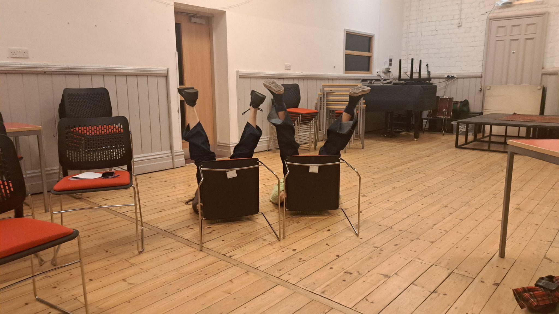
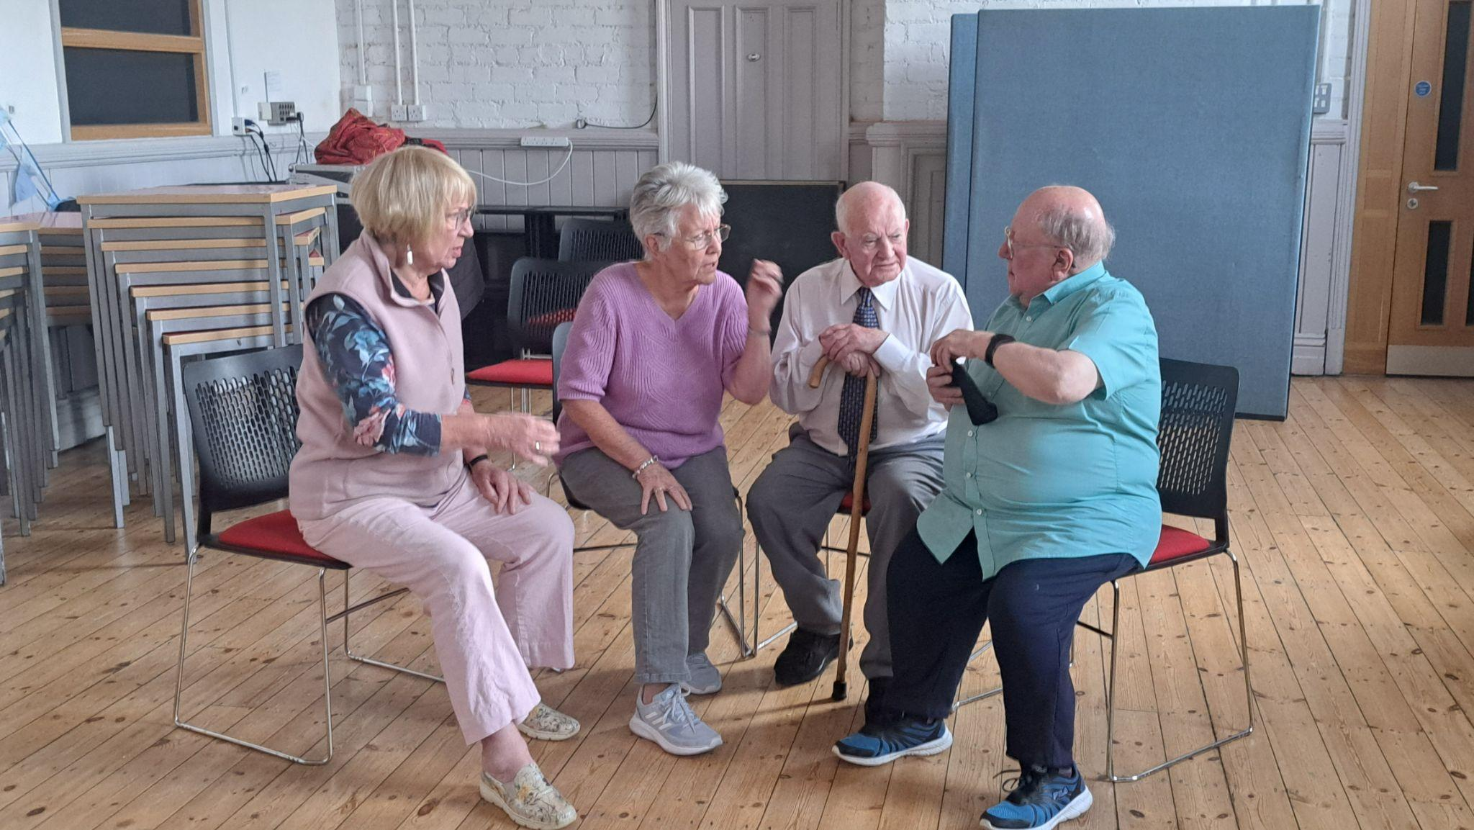

Creative Wellbeing in Care Homes

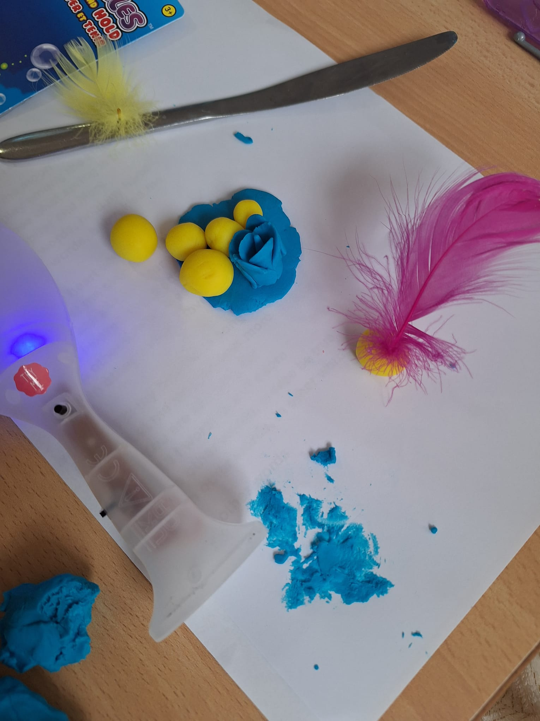

Rod Puppet Making Masterclass

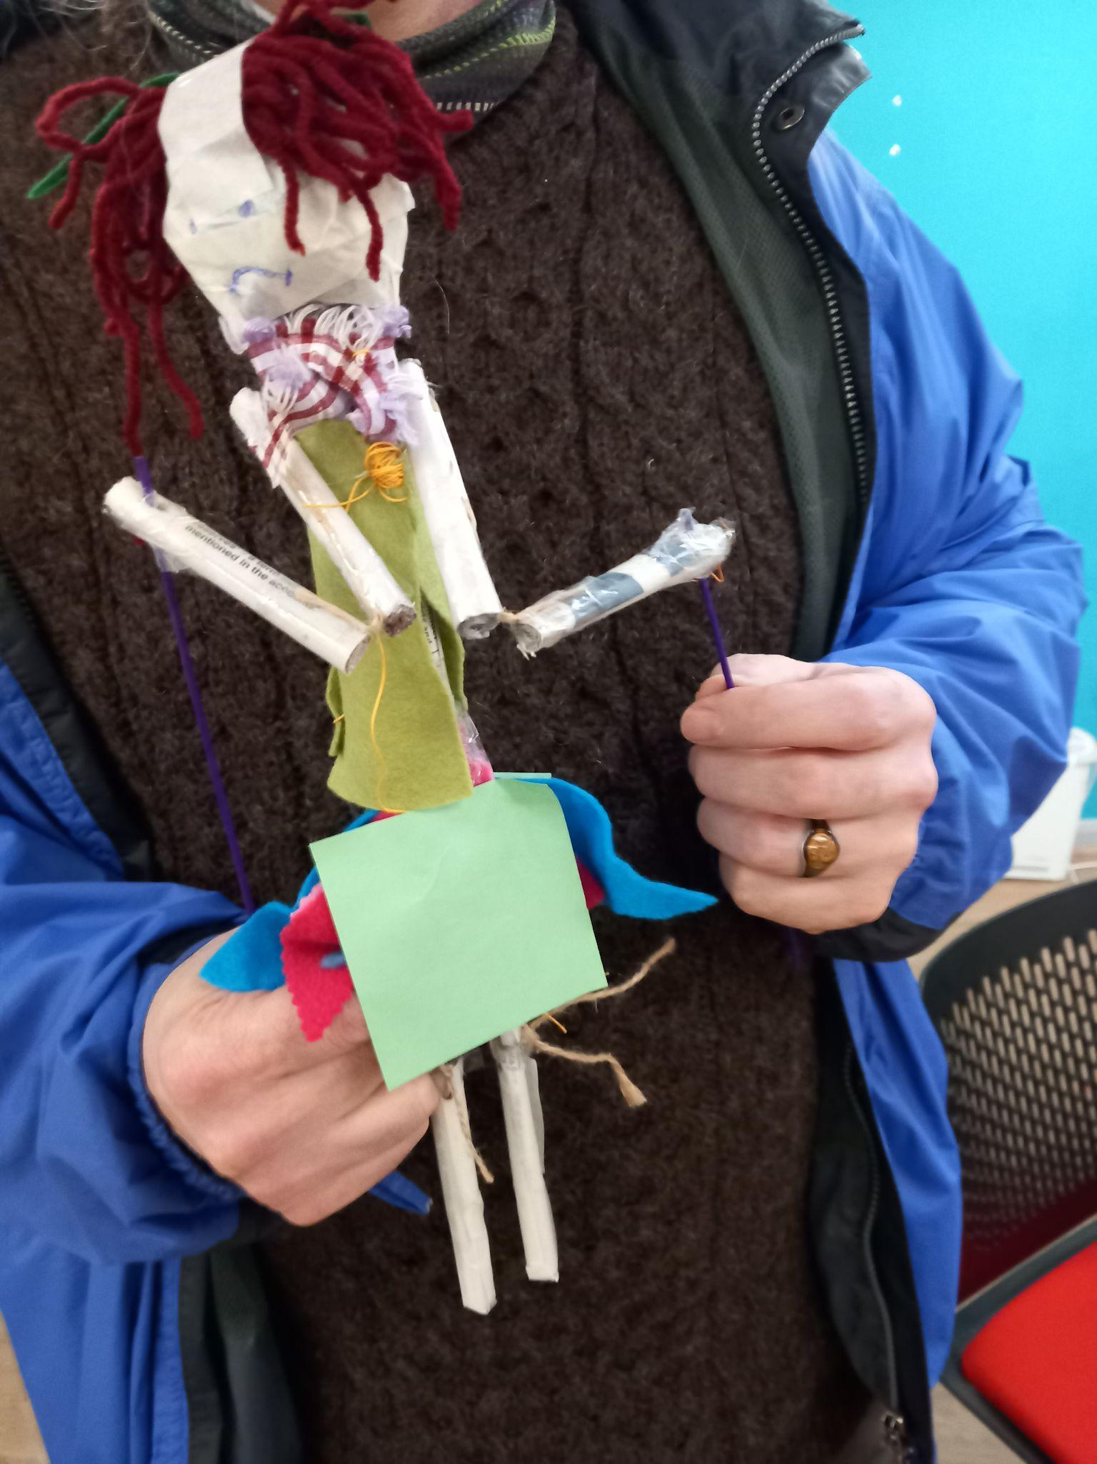

Summer Party

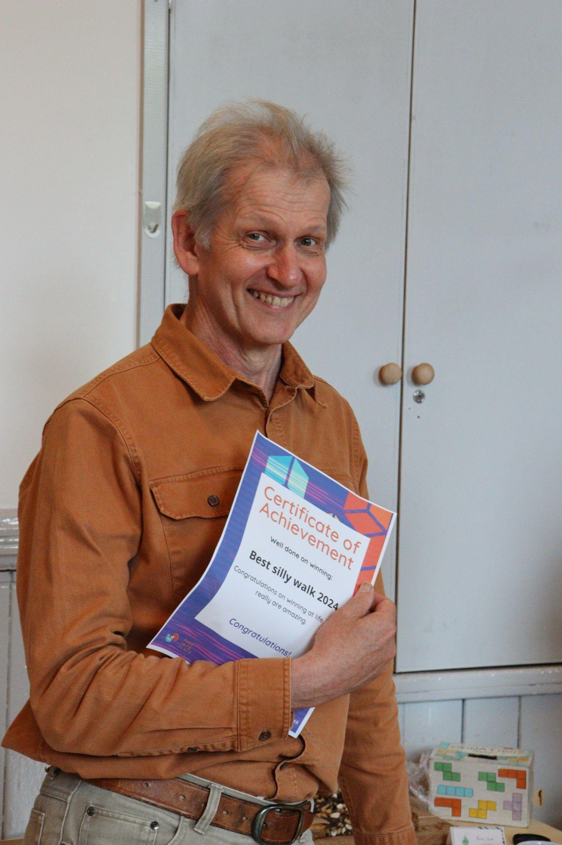

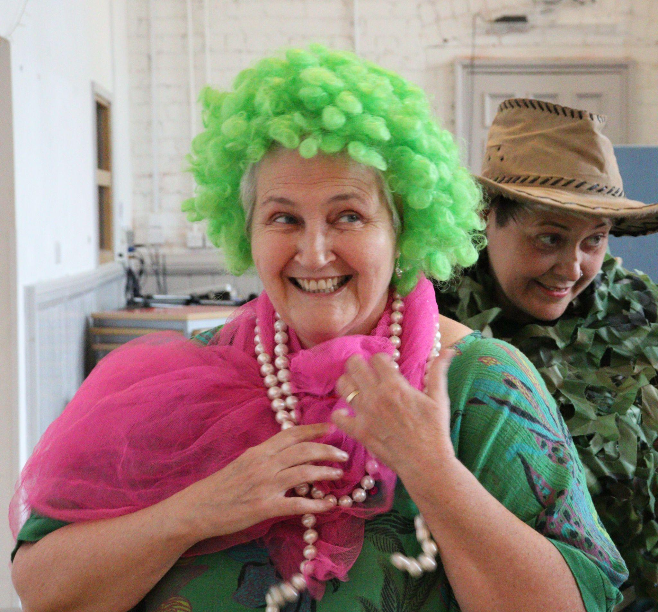

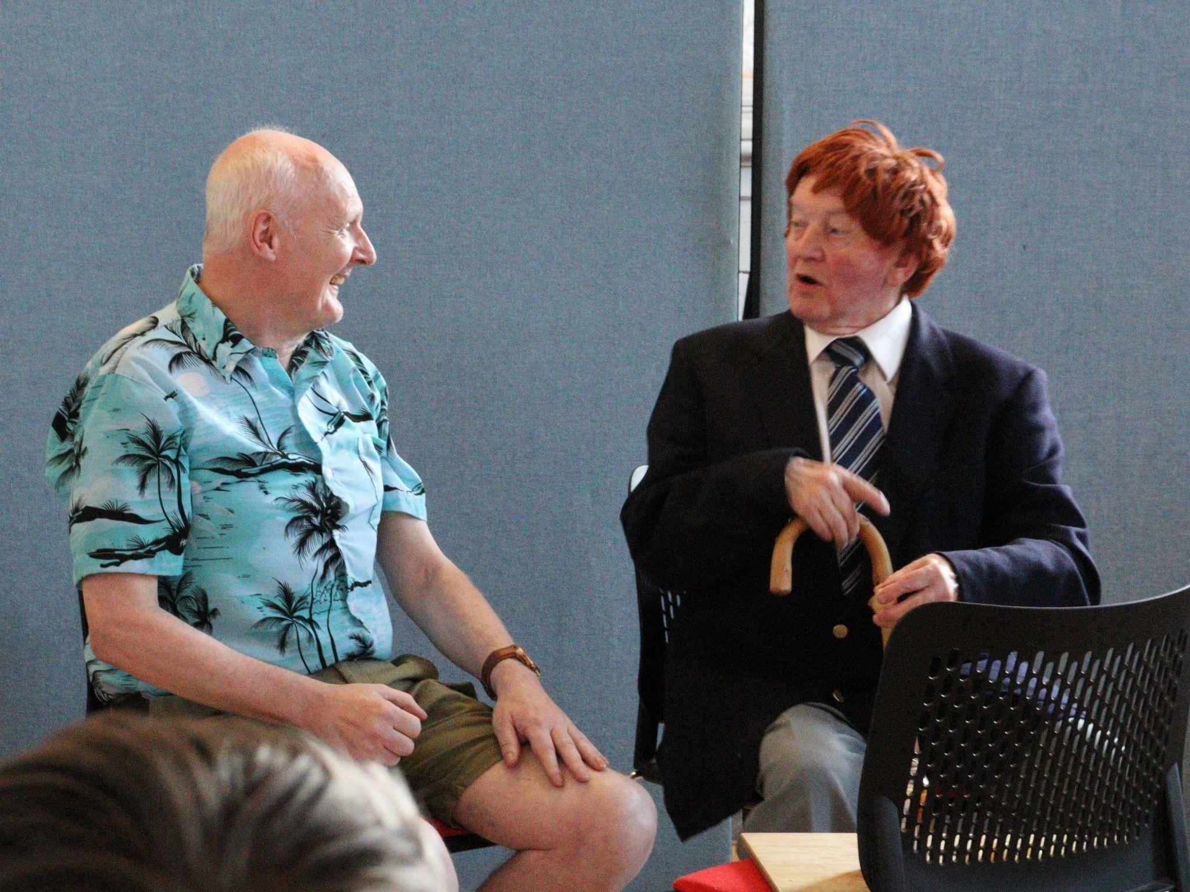

Creative Voices

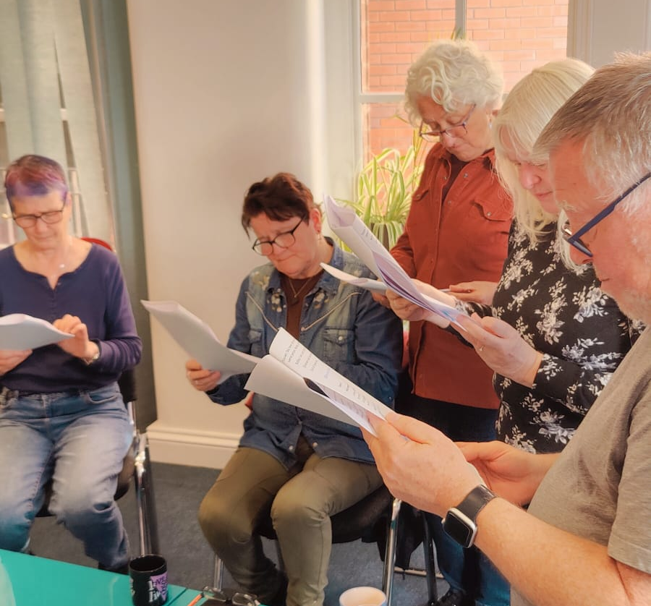

Staff Celebration

